Use of Service

Create project ng new servicedemo

Move: cd servicedemo

Execute: ng serve

Create service: ng g s user

Create component: ng g c user

Create user.ts file in app folder: user.ts

export class User{

    fname:string;

    lname:string;

    email:string;

}

Write below mentioned code in user.service.ts

import { Injectable } from '@angular/core';

@Injectable({

  providedIn: 'root'

})

export class UserService {

  constructor() { }

  getData(){

    return {fname:"sonam",lname:"Soni",email:"Sonam@123"}

  }

}

Similarly you can add more methods

You can inject service in component for use

User.component.ts

import { Component, OnInit } from '@angular/core';

import { User } from '../user';

import { UserService } from '../user.service';

@Component({

  selector: 'app-user',

  templateUrl: './user.component.html',

  styleUrls: ['./user.component.css']

})

export class UserComponent implements OnInit {

  user:User;

  constructor(private service:UserService) { }

  ngOnInit(): void {

    this.user= this.service.getData();

  }

}

When component initialized it going to call service getData() method which will load data in user object. That we can print in HTML file

User.component.html

<h1>User DATA</h1>

<ul>

    <li>First Name: {{user.fname}}</li>

    <li>Last Name: {{user.lname}}</li>

    <li>Email Id: {{user.email}}</li>

</ul>

Inject your user component in app component

App.component.ts

<h1> Service Demo</h1>

<app-user></app-user>

Also register service in list of providers

App.module.ts

import { NgModule } from '@angular/core';

import { BrowserModule } from '@angular/platform-browser';

import { AppRoutingModule } from './app-routing.module';

import { AppComponent } from './app.component';

import { UserService } from './user.service';

import { UserComponent } from './user/user.component';

@NgModule({

  declarations: [

    AppComponent,

    UserComponent

  ],

  imports: [

    BrowserModule,

    AppRoutingModule

  ],

  providers: [UserService],

  bootstrap: [AppComponent]

})

export class AppModule { }

also there is strict property initialization error you will get to remove

open tsconfig.json and add below property in compiler Option

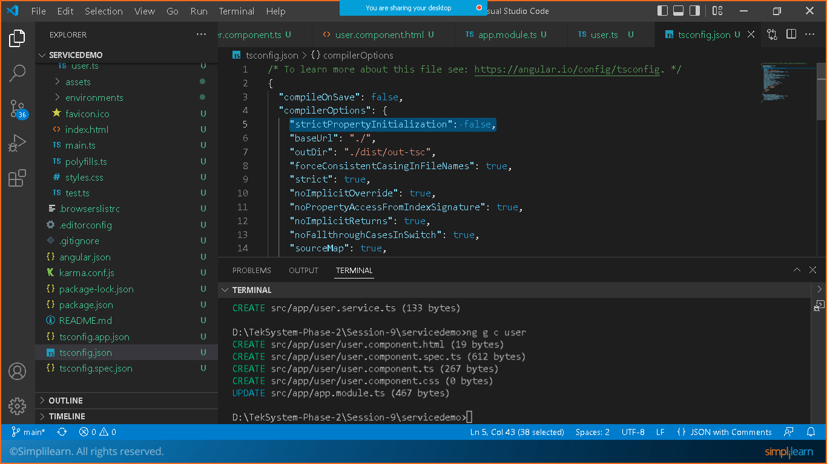

Save and check the output.